
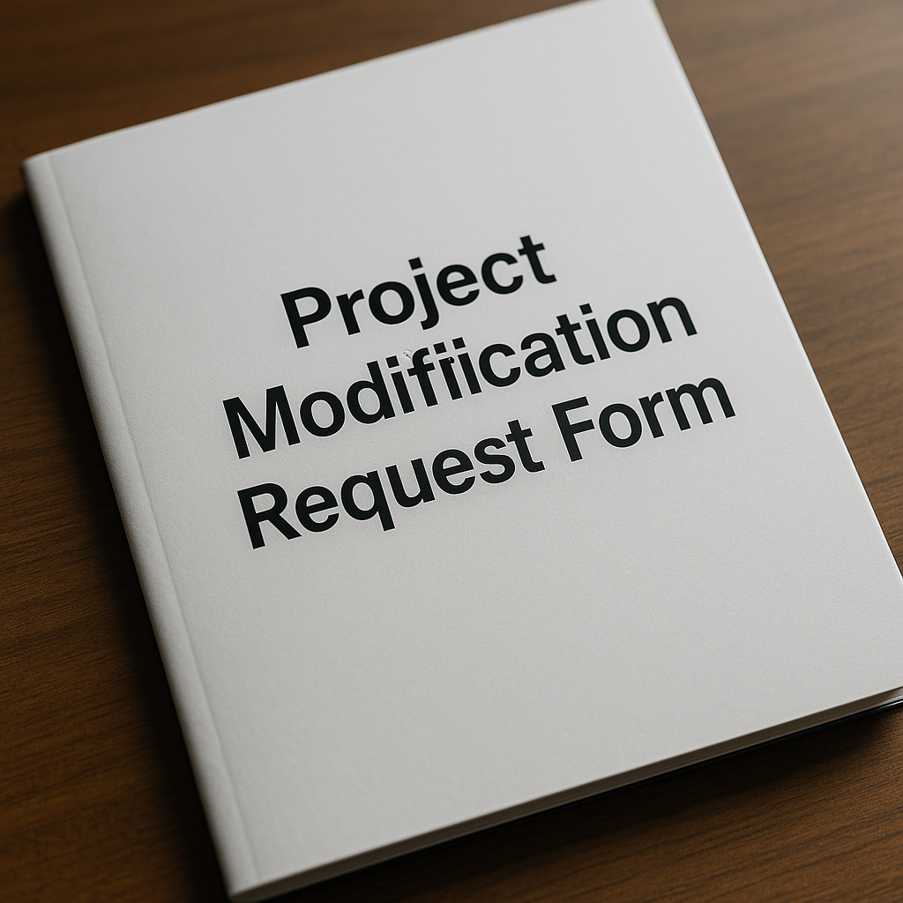
Project Modification Request Form

GCO-PMRF-001 (V1.0)

Introduction
This Project Modification Request Form (PMRF) provides a standardized mechanism to propose and document any changes to the original research plan and agreement between the Research, Development, and Innovation Authority (RDIA) and the research team.
- Please complete all applicable sections of this project modification request form and ensure proper reference and inclusion of any supporting documents before sharing with your RDI Unit representative via formal email communication.
- Ensure that all the information provided is consistent with the signed agreement.
- The Principal Investigator (PI) is responsible for ensuring the accuracy and completeness of all submitted information.
- The PI may transfer funds between budget line items once during the grant period, provided that the total value of the transfer does not exceed 20 % of the grant budget and that RDIA is notified of the change.
- The PI may reallocate up to 50 % within the research team’s compensation budget to cover additional post-doctoral hires if needed, subject to:
  - Written approval from all affected research-team members.
  - Acceptance of the justification by RDIA
- With prior written approval from RDIA, the PI may undertake the following:
  - Carry‐forward Balances: Transfer remaining funds from a given line item in one fiscal year to the same line item in the next fiscal year.
  - Intra‐budget Transfers: Reallocate funds between approved budget line items within the Investigator’s authorized limits.
  - Unbudgeted Procurements: Procure materials or equipment not originally included in the approved budget, provided such purchases do not exceed 20 % of the relevant line-item value.
- No modification to the grant agreement may be implemented without prior written approval from RDIA. All requests must be submitted in writing through this form and cannot take effect until formally approved.

General Information
Proposal Number | #####-XXX-YYYY-XXX-X-#-#-XX-
Proposal Title | Title must be in line with the signed agreement
Program/Initiative name | (Saudi Basic Science (SBS), Saudi Applied Research and Technology (SART), Reactivating & Rebuilding of Existing Labs (RREL)
PI Full Name
PI Contact | (Mobile, Email Address)
University/Research Entity Name - Branch | E.g., King Abdulaziz University – Jeddah branch
Project Starting Date | MM/DD/YYYY (Information must be consistent with Technical Report)
Project Duration | In Months (Duration must be in line with the signed agreement)
Date of Submission of the Modification Request | MM/DD/YYY

Type of Modification Requested (Check all that apply)
☐ Personnel & Resources Modifications
☐ Budget Modifications
☐ Timeline Modifications
☐ Deliverables & Milestones Modifications
☐ Impact on Other Projects (if applicable)
☐ Detailed Budget Breakdown (For budget modifications)
☐ Contingency / Mitigation Plan (if the requested modification is not approved)
☐ Change Log
☐ Other, please specify:

Personnel & Resources Modifications
Provide a clear explanation of the requested change, its impact on project objectives, justification with supporting documents if applicable, and a mitigation plan to maintain project goals.
☐ Modifications in Personnel & Resources
☐ Transfer authority of PI to an alternative PI
☐ Replace an Secondary PI
☐ Add an Secondary PI
☐ Replace a Research Assistant
☐ Add a Research Assistant
☐ Other, please specify:
Details of the Request (Explain in detail the reason for the requested change. Explain the effects of the change on the objectives, outcome, and management plan of the project):
<Insert details of the request here>

Justification (When applicable, clarify with necessary documents and evidence the need for
the requested change):
<Insert details of the justification here>

Please complete the table below for each supporting document you attach to this modification request:
<In this section, please provide a narrative list of all files or materials you are attaching to support your modification request. For each item, include:
- File Name / Reference: Exact name of the document (or hyperlink/reference code if stored in a shared repository)
- Date: When the document was created or issued (DD/MM/YYYY)
- Description / Purpose: A one-sentence summary of what the document is and how it supports your request>

Example:
- Email approval from Co-PI.pdf (15/06/2025) – Written confirmation from Co-PI Dr. A that they will assume responsibility for Task 2 following personnel change.

Commitment (State clearly the negative impact of the requested change on the outcomes of
the project and the mitigation plan to ensure that the proposed originality of the project
will be maintained):
<Insert details of the mitigation plan here>

Budget Modifications
Provide a clear explanation of the budget modification, its impact on project objectives, justification with supporting documents if applicable, and a mitigation plan to ensure financial sustainability and project success.
☐ Modifications in Budget/Funds
☐ Increase the budget fund from ( SAR) to ( SAR)
☐ Transfer between 'items' within the budget
☐ Other, please specify:
Details of the Request (Explain in detail the reason for the requested change. Explain the effects of the change on the objectives, outcome, and management plan of the project):
<Insert details of the request here>

Justification (When applicable, clarify with necessary documents and evidence the need for
the requested change):
<Insert details of the justification here>

Please complete the table below for each supporting document you attach to this modification request:
<In this section, please provide a narrative list of all files or materials you are attaching to support your modification request. For each item, include:
- File Name / Reference: Exact name of the document (or hyperlink/reference code if stored in a shared repository)
- Date: When the document was created or issued (DD/MM/YYYY)
- Description / Purpose: A one-sentence summary of what the document is and how it supports your request>

Example:
- Budget Reallocation Memo.docx (10/06/2025) – Internal finance memo authorizing transfer of SAR 50,000 from equipment to consumables.

Commitment (State clearly the negative impact of the requested change on the outcomes of
the project and the mitigation plan to ensure that the proposed originality of the project
will be maintained):
<Insert details of the mitigation plan here>

Timeline Modifications
Provide a clear explanation of the timeline modification, its impact on project objectives, justification with supporting document if applicable, and a mitigation plan to ensure project milestones and deliverables remain on track.
☐ Modifications in Timeline
☐ Extend the duration of the project from [DD/MM/YYYY] to [DD/MM/YYYY]
☐ Other, please specify:
Details of the Request (Explain in detail the reason for the requested change. Explain the effects of the change on the objectives, outcome, and management plan of the project):
<Insert details of the request here>

Justification (When applicable, clarify with necessary documents and evidence the need for
the requested change):
<Insert details of the justification here>

Please complete the table below for each supporting document you attach to this modification request:
<In this section, please provide a narrative list of all files or materials you are attaching to support your modification request. For each item, include:
- File Name / Reference: Exact name of the document (or hyperlink/reference code if stored in a shared repository)
- Date: When the document was created or issued (DD/MM/YYYY)
- Description / Purpose: A one-sentence summary of what the document is and how it supports your request>

Example:
- Revised Gantt Chart v2.xlsx (12/06/2025) – Updated project timeline showing extended Milestone 3 date from 30/06/2025 to 31/08/2025.

Commitment (State clearly the negative impact of the requested change on the outcomes of
the project and the mitigation plan to ensure that the proposed originality of the project
will be maintained):
<Insert details of the mitigation plan here>

Deliverables & Milestones Modifications
Provide a clear explanation of the requested changes to the project’s deliverables or milestones, its impact on project objectives, justification with supporting documents if applicable, and a mitigation plan to ensure that overall project goals remain achievable.
☐ Modifications to existing deliverable(s)/milestone(s)
☐ Change milestone due date from [DD/MM/YYYY] to [DD/MM/YYYY]
☐ Remove an existing deliverable/milestone
☐ Add a new deliverable/milestone
☐ Other, please specify:
Details of the Request (Explain in detail the reason for the requested change. Explain the effects of the change on the objectives, outcome, and management plan of the project):
<Insert details of the request here>

Justification (When applicable, clarify with necessary documents and evidence the need for
the requested change):
<Insert details of the justification here>

Please complete the table below for each supporting document you attach to this modification request:
<In this section, please provide a narrative list of all files or materials you are attaching to support your modification request. For each item, include:
- File Name / Reference: Exact name of the document (or hyperlink/reference code if stored in a shared repository)
- Date: When the document was created or issued (DD/MM/YYYY)
- Description / Purpose: A one-sentence summary of what the document is and how it supports your request>

Example:
- Revised Gantt Chart v2.xlsx (12/06/2025) – Updated project timeline showing extended Milestone 3 date from 30/06/2025 to 31/08/2025.

Commitment (State clearly the negative impact of the requested change on the outcomes of
the project and the mitigation plan to ensure that the proposed originality of the project
will be maintained):
<Insert details of the mitigation plan here>

Other Modifications
Provide a clear explanation of other modifications required, its impact on project objectives, justification with supporting documents if applicable, and a mitigation plan to ensure project milestones and deliverables remain on track.
☐ Other Modifications
Please specify any other modifications that are required
Details of the Request (Explain in detail the reason for the requested change. Explain the effects of the change on the objectives, outcome, and management plan of the project):
<Insert details of the request here>

Justification (When applicable, clarify with necessary documents and evidence the need for
the requested change):
<Insert details of the justification here>

Please complete the table below for each supporting document you attach to this modification request:
<In this section, please provide a narrative list of all files or materials you are attaching to support your modification request. For each item, include:
- File Name / Reference: Exact name of the document (or hyperlink/reference code if stored in a shared repository)
- Date: When the document was created or issued (DD/MM/YYYY)
- Description / Purpose: A one-sentence summary of what the document is and how it supports your request>

Commitment (State clearly the negative impact of the requested change on the outcomes of
the project and the mitigation plan to ensure that the proposed originality of the project
will be maintained):
<Insert details of the mitigation plan here>

Impact on Other Projects (if applicable)
Describe whether this modification affects other ongoing or planned projects under the same PI or institution. Include shared resources, timelines, or budget dependencies.

Detailed Budget Breakdown (For budget modifications)
Budget Item | Original Amount (SAR) |  |  | Modified Amount (SAR) |  |  | Difference (SAR) |  |  | % Change |  |  | Justification

Contingency / Mitigation Plan (if the requested modification is not approved)
Describe how the project will proceed if the requested modification is not approved, including alternative strategies, reduced scope, or reallocation of internal resources.

Other, please specify:
<Insert details of the request here>

Risk Assessment (if the requested change is not approved)
Risk |  |  | Description |  |  | Likelihood (Low/Med/High) |  |  | Impact (Low/Med/High) |  |  | Mitigation Action
Change Log
Change ID |  | Date Submitted |  |  | Type of Change |  |  | Description |  |  | Status (Approved / Pending / Rejected)

Principal Investigator Signature
☐ I, the Principal Investigator, confirm that the information provided in this Project Modification Request is accurate and complete to the best of my knowledge. I acknowledge that any approved modifications related to personnel, resources budget, timeline, or deliverables, must comply with RDIA guidelines and regulations. Additionally, I understand that any potential risks or impacts resulting from these changes must be mitigated as outlined in this request.
PI Name |  | Date | [DD/MM/YYYY] | Signature
RDIU-QA |  | Date | [DD/MM/YYYY] | Signature
RDIU Approval |  | Date | [DD/MM/YYYY] | Signature

RDIA Approval Signature (For RDIA use only)
Request Status | ☐ Approved |  | ☐ Rejected |  |  | ☐ Requires Revision
Additional Comments
Name | Dr. Rashid M. Altmaimi | Date |  | [DD/MM/YYYY] | Signature

